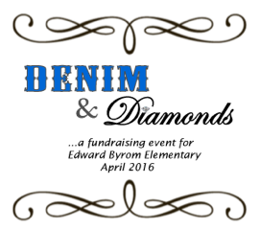

**Classroom Projects:**

Create a unique piece of art that all the children in the class have a hand in doing. Each project has a budget of $50 from the PSO. You will have to purchase materials or have them donated. You will then turn in your receipts into the PSO and will be reimbursed.

There are several websites that help in creating a fun project and you can find great ideas on Pinterest.

If you are interested in taking on this fun opportunity, please contact Nikki Castillo at [nikkicastillo@yahoo.com](mailto:nikkicastillo@yahoo.com). Projects must be completed by Friday, February 20th.

To see past auction projects, you can check them out on Facebook at www.facebook.com/ByromElementaryAuction

Byrom’s Auction and Party is set for Saturday, April 2 at Living Savior Church. One of the most popular and biggest moneymakers for our school are the classroom themed baskets and classroom projects. We are looking for volunteers to take on the responsibility of putting together each classrooms basket and project.

**Classroom Baskets:**

If you are interested in being the basket coordinator for your grade level, please contact Shelly Barrett at [shellybarrett22@gmail.com](mailto:shellybarrett22@gmail.com). We are looking for at least two coordinators per grade.

**Themes**

Kindergarten- Ducks/Beavers/Timbers

1st Grade- Baking /Cooking and Sunrise/Good Morning (coffee/tea/bread mixes)

2nd- Sports and Family Fun Night

3rd- Art and Chocolate Lovers

4th- Italian Food/wine and Gardening

5th- Pampering/Spa and Date Night Out

* If you have an idea for a theme and would like to donate your own basket, please feel free to contact Shelly.
* In addition to your class theme, if you have any access to items through work or unopened items lying around your house that would be a good addition to another basket, we will accept all unused donations! Alcohol will need to be delivered/picked up outside of school grounds.